Ex. No.: 3a)
Date:
Shell Script – Reverse of Digit
Aim:
To write a Shell script to reverse a given digit using looping statement.

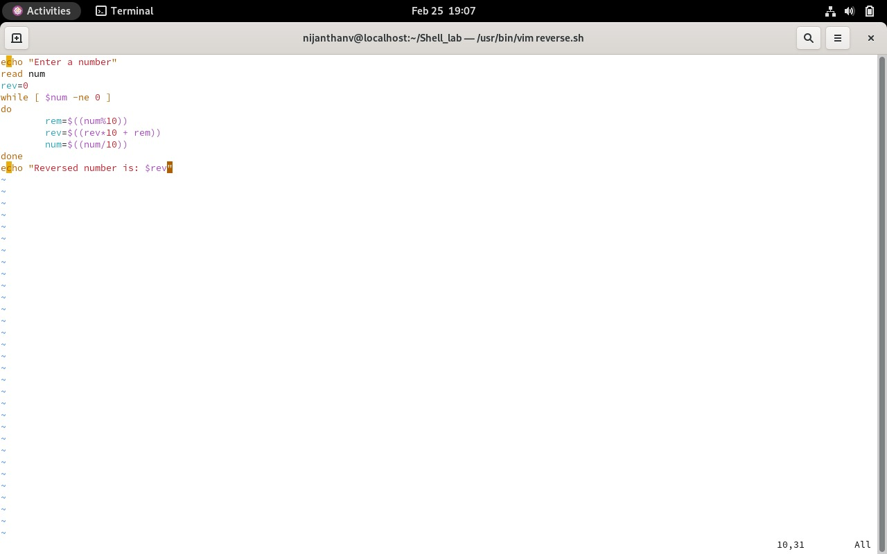

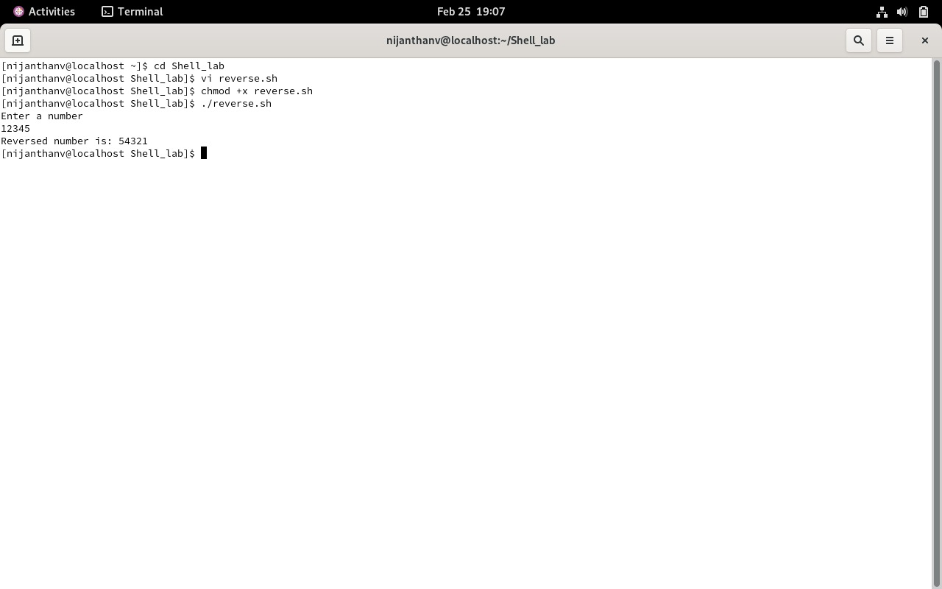

Ex. No.: 3b)
Date:
Shell Script – Fibbonacci Series
Aim:
To write a Shell script to generate a Fibonacci series using for loop.
